**A. Installing SyncroSim**

* 1. To install **SyncroSim**, go to [**https://syncrosim.com/**](https://syncrosim.com/) and download either of the versions listed there for Windows. Note that SyncroSim evolves constantly and as a result, the screen or the versions of the software that the students see when installing it might change frequently, but they should still be able to install it without any problems. It is also our experience that when installing SyncroSim, it might be helpful to use the *Stable* version rather than the *Beta* version, if both are given at the time of your installation
     + If you get a message about your Microsoft defender preventing this app from installing ( e.g., “Microsoft Defender SmartScreen prevented an unrecognized app from starting. Running this app might put your PC at risk”), just click the “**more info**” tab below the message and it should give you an option to install anyway. If you get another screen with warning, just click the “**run this program anyway**” option
     + **It may ask you to create an account** as part of the installation process, or even to **activate the software with a license** that they give you on the screen. Just follow the instructions and do all that is asked.
  2. To open it after installing, just go to your windows icon and search for it among your apps. Typically, there’s only one version installed, but sometimes, you may see two versions when opening it. If so, open the “**New**” version, not the “**lite**” one.
  3. The first time you open Syncrosim, you may get a screen like the one below (Fig 1), that says that a certain package needs to be installed before it can run. If you get this, just click **ok**.

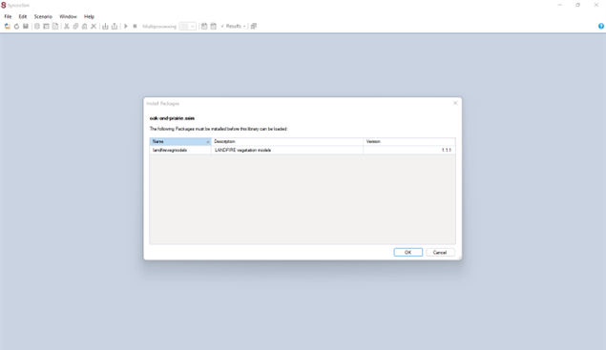

Fig 1. Screen image asking you to accept package installation

* 1. When the installation is successful, your SyncroSim screen should look as follows (Fig 2). It is ready to go.

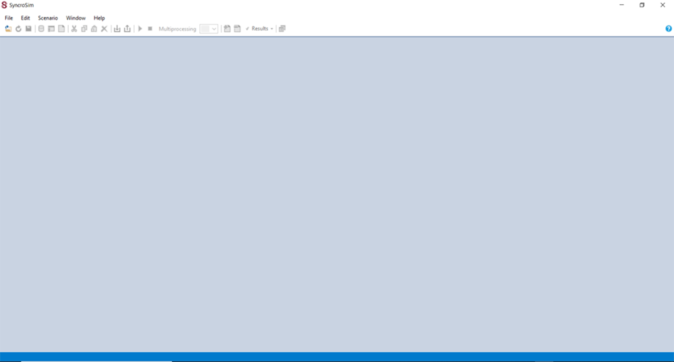

Fig. 2: How the SyncroSim platform should look when it’s opened after a successful installation

**B. Installing/Updating required packages for SyncroSim to work**

* Once you install SyncroSim, it is also highly recommended that you ensure that the software has all of the critical updates and packages to minimize running into problems once you start work. Checking for any updates is recommended.
* Once SyncroSim is installed, take the following steps to ensure that two critical packages that you will need are installed and ready to go.
* The two critical packages that you need to make sure are good to go are below.
  + **landfirevegmodels**
  + **stsim**

**How check if the two packages are ready**

* Open SyncroSim to have the screen as in Fig 2 above.
* Click *File*, then in the resulting box, click *Packages* (third option from the bottom). A packages window will pop up.
  + If the above two items (landfireveg models and stsim) are installed and ready to go, they should show up in that packages window, as seen in Fig 3 below.
  + If this is the case, then you can exit this packages window. It just means you do not have to update anything because these two packages are good to go.

Fig.3. The two critical packages that should show up in packages list

* + However, if none of those two packages show up in the Fig 3 window, or if only one of the two shows up, it means that you need to do some updating to install both of them (if both are missing in the list) or install the one that is missing (if only one is missing in the list).
* To update missing packages, click the *Install* tab that is at the bottom left corner of the Packages window (circled in red in Fig 3 above).
* A list of packages will appear, something similar to the ones in the window in Fig 4 below.

Fig 4. List of all packages that SyncroSim has and from which to select the two needed packages

* Put a check mark in the box next to both **landfirevegmodels** and the **stsim** packages in that list (if both were missing) OR put a check in the box next to whichever one was missing (if only one was missing); Note: If only one was missing, it tends to be the **stsim** one that would be missing.
* Click *OK*. Your packages should now be updated and you should now be all set. Exit the Packages window.
* Just to be sure, you can click *file* again, then *packages*, and check to see that the resulting packages window has the two packages listed, just like Fig 3 above.